Final Exam Supplemental Handout
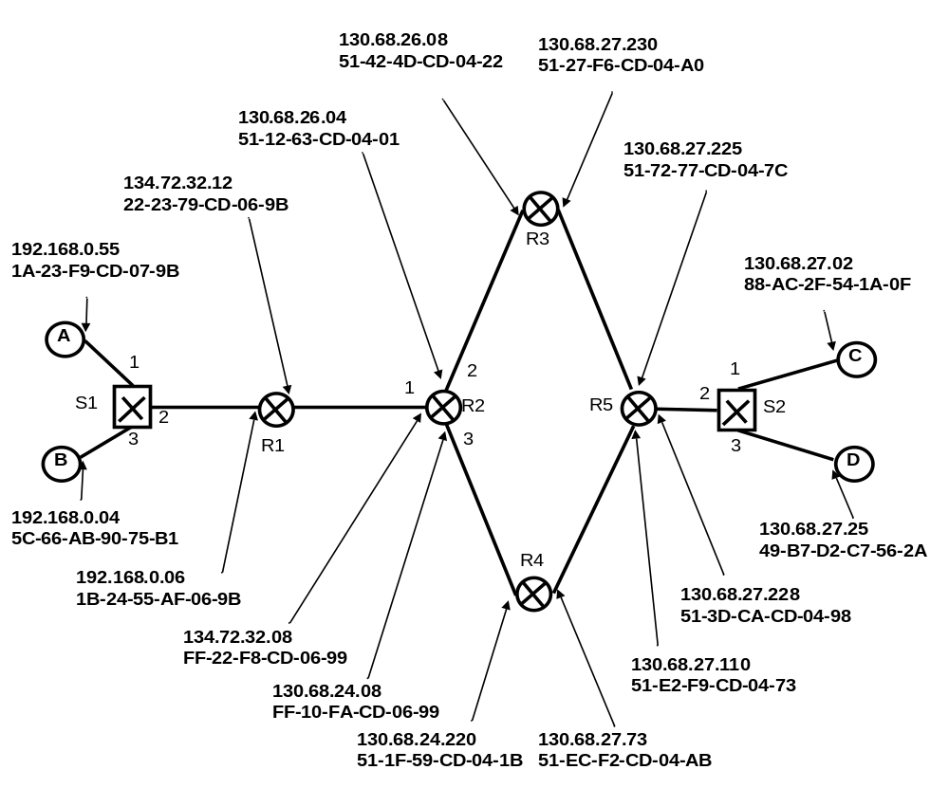
Figure 1: Network Diagram

ARP Table for A

IP Address | Mac Address
192.168.0.04 | 5C-66-AB-90-75-B1

Switch Table for S1

Mac Address | Interface
1B-24-55-AF-06-9B | 2
5C-66-AB-90-75-B1 | 3
…

NAT Table for R1

R1 NAT Translation Table
WAN side address | LAN side address
134.72.32.12, 3250 | 192.168.0.55, 4505
134.72.32.12, 3200 | 192.168.0.55, 2200
134.72.32.12, 2400 | 192.168.0.04, 3000
134.72.32.12, 2250 | 192.168.0.04, 2230

R2 Forwarding Table

Prefix | Link Interface
10000010 01000100 0001101 | 2
10000010 01000100 00011 | 3
10000110 01001000 | 1
Otherwise | 4

Switch Table for S2

Mac Address | Interface
51-3D-CA-CD-04-98 | 2

